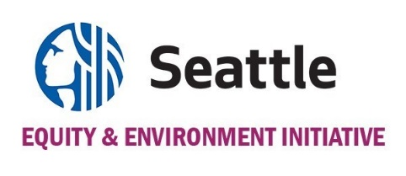

GREEN NEW DEAL OVERSIGHT BOARD FINANCIAL HARDSHIP COMPENSATION REQUEST FORM

As an individual working at the nexus of race, social, economic, and environmental justice, your expertise strengthens the Green New Deal Oversight Board (GNDOB), but your participation may require time away from other personal and professional commitments.
Therefore, a stipend is available to all members who may face a financial hardship for their time serving on this board. A financial hardship for this purpose is defined, but not limited to; covering the cost of hourly wages lost, childcare needs, transportation, or any financial barrier that may hinder your full participation on the board.
- Members facing a financial hardship for their participation may use this form to request compensation of $50 per hour, up to 8 hours per month, for their service to the Green New Deal Oversight Board.
- Members serving in a leadership role may be eligible to receive an additional $750/year for additional hours required of their service.
Please complete the following affidavit to request compensation if participating on the Board presents a financial hardship. Once this request is reviewed and approved, your Board Staff Liaison will follow up to schedule a meeting to go over invoicing instructions.

------------------------------------------------------------------------------------------------------------------------------------------

I __________________ am requesting compensation for participating on the Green New Deal Oversight Board. In order to receive this compensation, an invoice document shall be submitted with a summary of my work activities completed serving on the Green New Deal Oversight Board.

_________________________ _____________________________
Signature Date

